# Configuring mail server in Jenkins ( Gmail )

# **Pre-requisite**

* running Jenkins server
* Gmail account with insecure apps enabled

## **setup**

Install Email Extension Plugin in Jenkins

Once plugin installed in jenkins, click on manage jenkins --> configure system there under E-mail Notification section configure the details as shown in below image

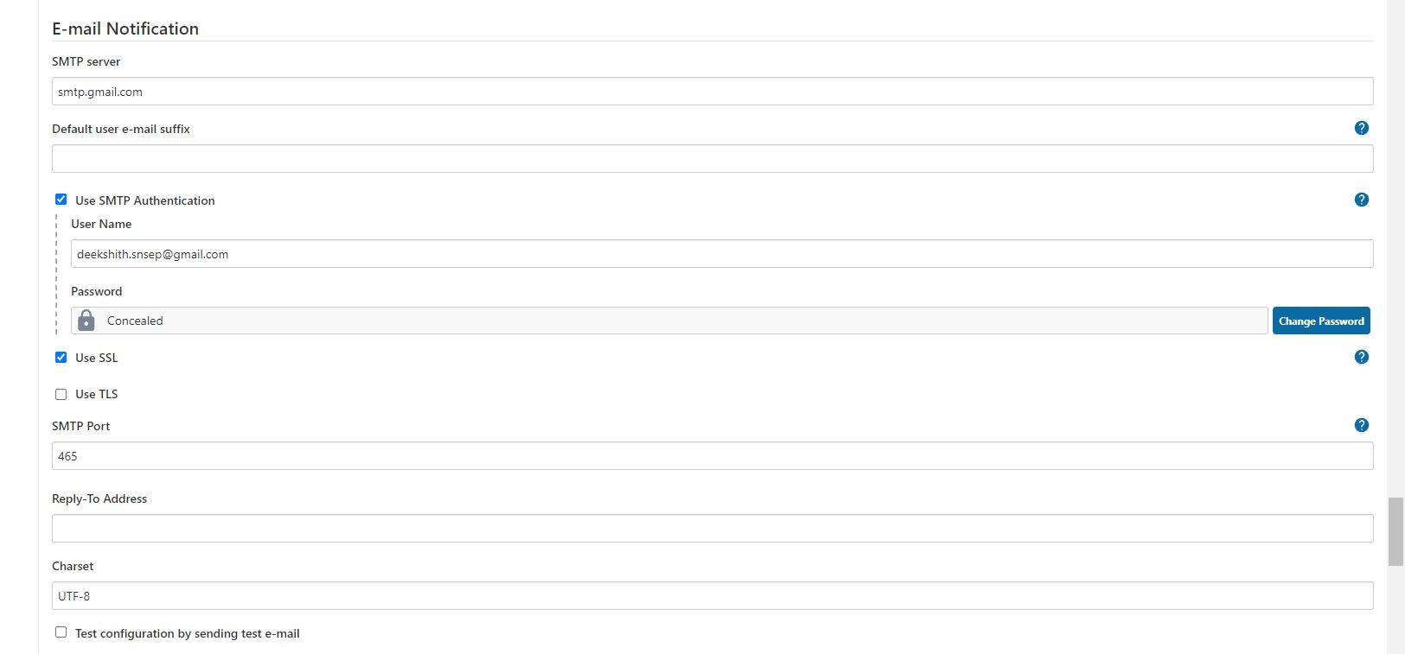

this is to just verify mail configuration

Now under Extended E-mail Notification section configure the details as shown in below images

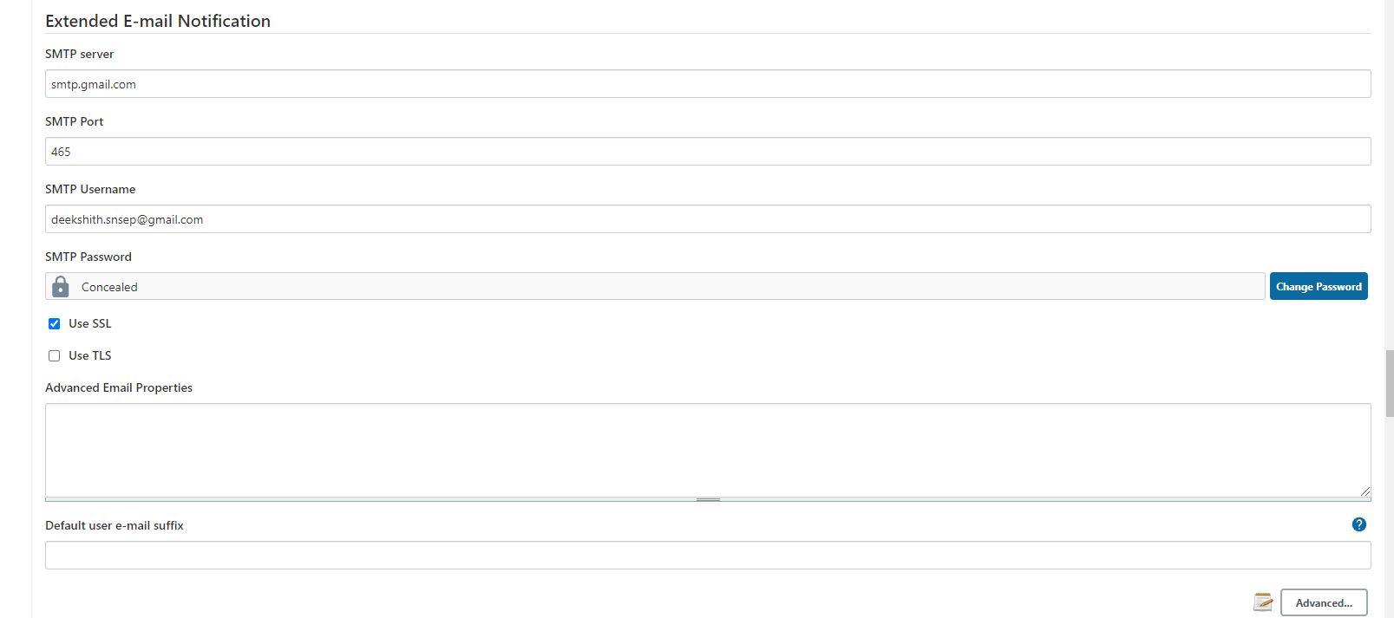 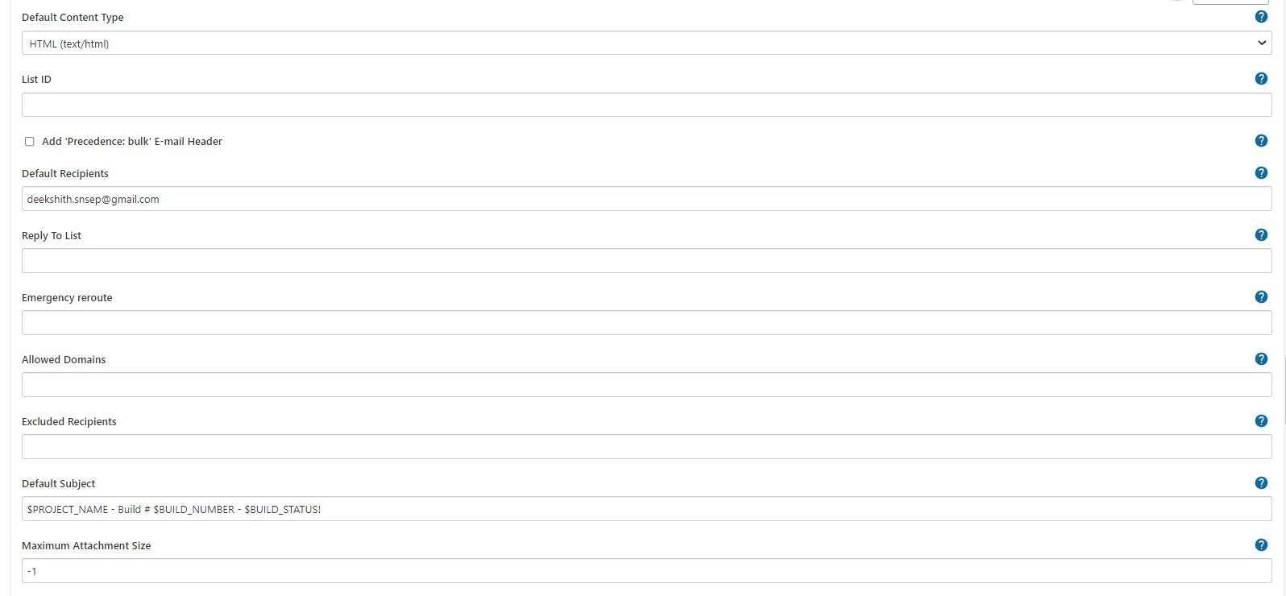 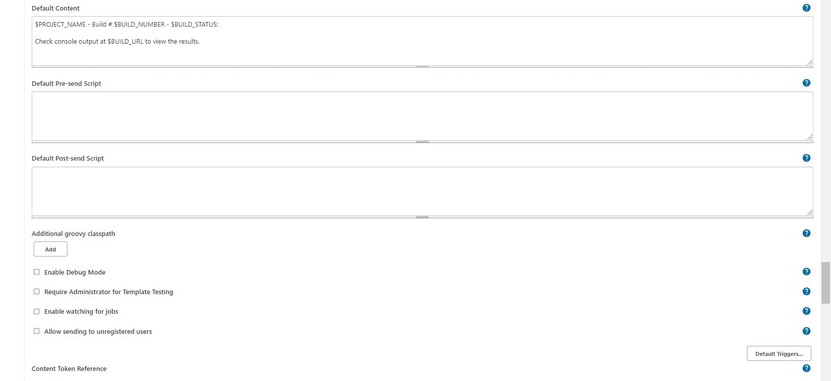

By using below code i can send customized mail

post {

always {

mail bcc: '', body: "<br>Project: ${env.JOB_NAME} <br>Build Number: ${env.BUILD_NUMBER} <br> URL de build: ${env.BUILD_URL}", cc: '', charset: 'UTF-8', from: '', mimeType: 'text/html', replyTo: '', subject: "${currentBuild.result} CI: Project name -> ${env.JOB_NAME}", to: "deekshith.snsep@gmail.com";

}

}

also which ever the mail you use for authentication in that mail setting "Less secure apps access" should be enabled

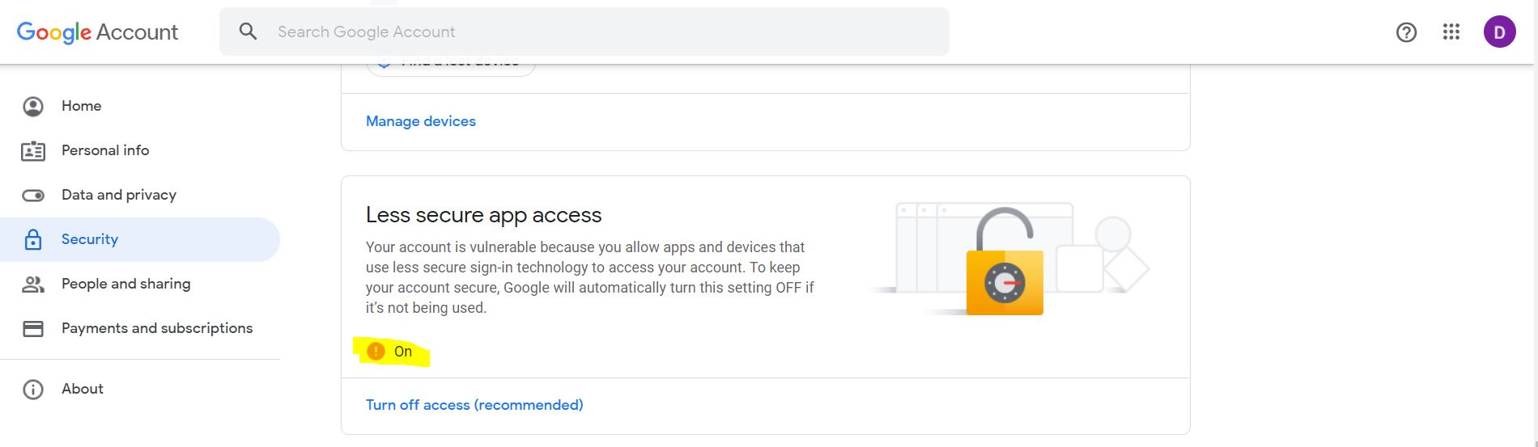

Sometimes we need do extra setting <https://g.co/allowaccess> allowed access from outside for a limited time and this solved my problem.

Default Subject

$PROJECT_NAME - Build # $BUILD_NUMBER - $BUILD_STATUS!

$PROJECT_NAME - Build # $BUILD_NUMBER - $BUILD_STATUS:

Check console output at $BUILD_URL to view the results.